# Methods

## Stryke

Kleinschmidt assessed whole project passage survival with the open source software package stryke[1]. Stryke is an individual based model (IBM), which follows the fate of a population of fish as they migrate past a hydroelectric project. Movement and survival are simulated with Monte Carlo methods. The software is written in Python 3.7.x and utilizes SQLite[2] for data management, Networkx[3] to simulate routes of passage, and Numpy[4] for pseudo-random probability distribution draws. Kleinschmidt has validated stryke with the USFWS blade strike simulation tool[5]. Most importantly, stryke is scalable; it is possible to model complex movement through multiple facilities and incorporate effects of migratory delay.

Fish move through a hydroelectric project where migratory routes are described with a directed acyclic graph. Fish are obligated downstream migrants. If fish survive their current node, they can move to the next one in the graph. If there is more than one node available at their current location, then a Monte-Carlo role of the dice and *a priori* determined transition probabilities control their movement. The simulation ends for a fish when it arrives at the last node in the migratory network or dies.

For fish passing via entrainment, individuals are exposed to turbine strike, which is modeled with the Franke et. al. 1997 equations. For fish that pass via passage structures or spill, mortality is assessed with a roll of the dice using survival metrics determined *a priori*, sourced from similar studies, or via expert opinion. The Franke et al. equations calculate the probability a fish of a given length will get struck by a turbine runner blade. Essentially, if we know how long a given fish is, the velocity of the water as it travels through the turbine, the type of turbine, how many blades and how fast it is rotating, we can calculate, with certainty, the probability of being struck. For simplicity, we assume that all blade strikes result in death.

## Turbine Parameters

The blade strike models derived by Franke et al. (1997) require accurate measurements of a suite of turbine parameters. The generating units at the Project are four Kaplan turbines of similar design (U1-U4) and a smaller Kaplan designed for min flow releases (U5). Required inputs for the blade strike model include: rated turbine head (ft), estimated maximum discharge (cfs), discharge at maximum efficiency (cfs), percent discharge at maximum efficiency, runner speed (rotations per minute, rpm), runner diameter (ft), runner diameter (ft), number of blades, and turbine efficiency (nameplate). These parameters were used to develop an initial blade strike model at units 1-4 and unit 5 (Table 1) for a suite of species at Cornell.

Table Cornell Kaplan Unit Parameters

|  |  |  |  |  |
| --- | --- | --- | --- | --- |
| **Parameter** | **Symbol** | **Units** | **U1-U4** | **U5** |
| Rated Turbine Head | $$H$$ | ft | 37 | 37 |
| Max. Discharge | $$Q$$ | cfs | 4200 | 400 |
| Efficient Discharge | $$Q_{opt}$$ | cfs | 3750 | 360 |
| Percent Discharge at Max. Efficiency |  |  | 90% | 90% |
| Runner Speed | $$ω=RPM*\frac{2π}{60}$$ | RPM | 100 | 450 |
| Runner Diameter | $$D$$ | ft | 15 | 4 |
| Number of Blades | $$N$$ |  | 5 | 5 |
| Turbine Efficiency | $$η$$ |  | 0.9 | 0.714 |

## Migratory Routes and Movement

The Cornell project is a traditional hydroelectric facility, where both obligate and opportunistic downstream migrants risk entrainment as they move downstream. The migratory network at Cornell is described with the following graph (Figure XX). Fish start in the forebay where they can either be entrained or pass via spill. Survival is assessed at every node. If a fish survives the passage state, they transition to the tailrace.

Fish are assumed to “follow the flow.” Therefore, if 90% of the river discharge is directed through the units, 90% of the simulated fish will become entrained and the remaining fish will spill. Seasonal flow routing scenarios were determined for a low, median, and high water year.

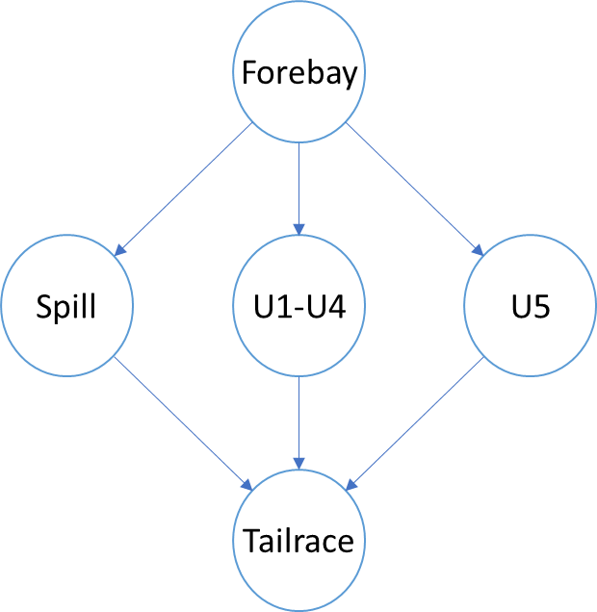

Figure shows the migratory routes at the Cornell project. Note, units 1 – 4 are a single node because each unit is identical. Discharge is assumed to be split equally among the 4.

## Node Survival

Stryke assesses survival for individual fish at each node within the migratory network. For the forebay and tailrace nodes, the survival probability was assumed to be 1.0. Since we are not concerned with effects of migratory delay, like we would with an obligated anadromous fish (e.g. juvenile alosine), we do not need to model natural mortality (e.g. predation). During times of high discharge, fish may spill over the dam. When spilling, survival was assumed to be high (90%). When a fish is entrained, survival at a turbine is assessed with the Franke et al. (1997) equations for Kaplan runners. The first step calculated the energy coefficient $E_{ωd}$ and is given with Equation 1:

|  |  |
| --- | --- |
| $$E_{ωd}=\frac{gH}{\left(ωD\right)}$$ | 2 |

where $E_{ωd}$ is the energy coefficient, $g$ is the acceleration due to gravity ($ft/s^{2}$), $H$ is the turbine net head (ft $)$, $ω$ is the rotational speed of the runner ($RPM*2π/60)$, and $D$ is the diameter of the runner (ft). Next, we calculate the discharge coefficient ( $Q_{ωd})$ with Equation 5:

|  |  |
| --- | --- |
| $$Q_{ωd}=\frac{Q}{ωD^{3}}$$ | 3 |

where $D^{3}$ is the diameter (ft) of the runner cubed. The relative flow angle ($β$) is given with Equation 6:

|  |  |
| --- | --- |
| $$\tan{β}=\frac{\frac{π}{8}*\frac{r}{R}}{{Q_{ωd}*Q}_{opt}}$$ | 4 |

where $Q_{opt}$ is the turbine discharge at best efficiency (${ft}^{3}/s$) and $\frac{r}{R}$ is the radius ratio, or where along the radius of the turbine runner struck the fish. Stryke simulates the radius ratio with a draw from a uniform probability between 0.3 and 1.0. Then, we calculated the angle of absolute flow to axis of the rotation with:

$$α_{α}=\tan^{-1}\left(\frac{π/2*E_{ωd}*η}{Q_{ωd}*r/R}+\frac{π/8*r/R}{Q_{ωd}}-\tan{β}\right)$$

Finally, the probability of mortality from blade strike $M^{d}$ during discharge model is given with Equation 7:

|  |  |
| --- | --- |
| $$M^{d}=λ\frac{N*L}{D}\left(\frac{\tan{α_{α}}}{8*Q_{wd}}+\frac{\sin{α_{α}}}{π*r/R}\right)$$ | 5 |

Where $λ$ is a strike mortality correlation factor, $N$ is the number of blades, and $L$ is the length of the fish (ft). A correlation factor (λ) was utilized in the Advanced Hydro Turbine (Franke et al. 1997) model to adjust the predictive model results to correspond with documented empirical results. This correlation factor was originally introduced by Von Raben (cited by Bell 1981) because the contact of a fish with a turbine component does not always result in injury or mortality (Bell 1981; Cada 1998). Therefore, Von Raben introduced the correlation factor to adjust the predicted turbine strike results to more closely match empirical results. This factor also extends the applicability of these predictive equations to all injury mechanisms related to the variable NL/D (see above for definition of parameters). As stated in Franke et al. (1997) "*such mechanisms could include mechanical mechanisms leading edge strike and gap grinding as well as fluid induced mechanisms related to flow through gaps or other flow phenomena associated with blades.*" Based on a substantial number of test results obtained from studies conducted with salmonids on the west coast, Franke et al. (1997) recommends that the correlation factor be set between 0.1 to 0.2.

## Simulation

Isha – please describe simulation

# Results

Isha – please describe results

1. <https://github.com/knebiolo/stryke>
2. <https://www.sqlite.org/index.html>
3. <https://networkx.github.io/>
4. <https://numpy.org/>
5. <https://www.fws.gov/northeast/fisheries/fishpassageengineering.html>